Calculon Excel Add-In: Developer’s Guide

Introduction
The aim of this document is to provide a detailed brief of the high-level functions presented in the Excel Add-In and the corresponding low-level steps in code which achieve them.
The purpose of the Excel Add-In is to enable a RAS designer to publish a RAS model (workbook) to a Calc Server and handle success or failure. Once published, it also enables the user to Test against the calc web service for that model.

Pre-Reqs
The development environment needs to be running Excel 2007 and Visual Studio Tools for Office. If a newer version is installed, then the resulting Add-In will not be backwards compatible to 2007.

Architecture
The Excel Add-In uses a ribbon menu to allow communication with one or more Calc Servers, enabling RAS designers to configure settings, publish and test their RAS spreadsheet models. A test Calc Server can be found here.
- Settings are stored internally to the workbook as Custom Document Properties for persistence
- Publish communicates with the Upload interface; a multipart upload page with some checkbox options
- Test communicates with the calc web service
These steps will be described in detail in this document.


CareConnect
Calc Server

Upload

Calc
CareFirst
CalcInt

The CalcInt adaptor is also supplied to provide 2-way integration with CareAssess (via CareConnect). It is outside of the scope of this document. For information, this adaptor can be launched directly from within Carefirst via a launcher menu, to synchronously score the assessment.
It can also be invoked by a JMS listener on the CareConnect queue; when SDS type assessments are completed, they are placed onto the CareConnect queue. The listener filters assessments which should be scored, using a properties file. For those which need to be scored, an xml request is created from the data and sent to Calc Server. The response is received, decoded and written back as a CareConnect put message on the queue. This updates the assessment header asynchronously.

WorkBook-Level Methods
On Startup, the Workbook creates an instance of CalculationModel class and attempts to set all properties by reading from the workbook Custom Document Properties.
If all get set, then the workbook is presented and the RAS ribbon group displayed.
If any are blank, then the Settings form is presented with any empty properties highlighted in red.
The workbook holds global methods to read and set custom document properties.

Classes
The main helper class is CalculationModel, whose members are shown to the right.
All Properties / Fields are mirrors of the settings that get stored as Custom Document Properties.
The purpose of each setting is described in the User Guide for RAS Designers.

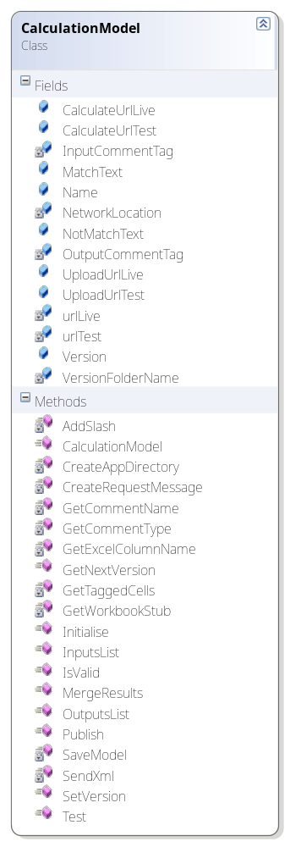
Public Methods
GetNextVersion | Takes inputs of the current version number and ‘minor|major’ increment type and returns the new version number
Initialise (string propertyName, string defaultPropertyVal) | Reads a custom document property propertyName. If empty, it sets the property with value defaultPropertyVal
InputsList | Returns a list of string arrays containing details of all Input cells in the workbook.  Uses private method GetTaggedCells
IsValid | Performs two tests to validate the workbook before publishing:  - If there are zero inputs or zero outputs, do not publish  - If there are any #REF errors, do not publish
MergeResults (List<string[]> resultsList) | Creates the results lists which is displayed in the results form.  It accepts a list of results from the Calc web service response and compares them with the OutputsList for the current model. It assigns match/not match text based upon tolerance.
OutputsList | Returns a list of string arrays containing details of all Output cells in the workbook.  Uses private method GetTaggedCells
Publish (string Environment) | Publishes the workbook to target environment (TEST|LIVE).  See Publish, below
SetVersion | Updates the version property
Test | Tests the workbook against last published environment (TEST|LIVE).  See Test, below

Private Methods
AddSlash | Adds a trailing slash to a url if none was supplied (used with Settings)
CreateAppDirectory (string path) | Boolean. Returns true if user is able to write versioned files to the target path
CreateRequestMessage | Creates an xml (SOAP) request to send to calc web service. Walks through all input cells to list key-values  Note: this method gives better results than WCF class
GetCommentName (string comment) | Returns the name of a comment for the supplied comment text (comment). It looks for the existence of a pattern <Tag>:<Ref> within the comment, where <Tag> can be I, O, or whatever is currently set using Settings and returns the value of <Ref>
GetCommentType (string comment) | Returns the type of a comment for the supplied comment text (comment), i.e. input or output. It looks for the existence of a pattern <Tag>:<Ref> within the comment, where <Tag> can be I, O, or whatever is currently set using Settings and returns the value of <Tag>
GetExcelColumnName (int columnNumber) | Converts an integer column into an Excel column, e.g. 27 == ‘AA’
GetTaggedCells (string cellType) | Returns a list of string arrays comprising all inputs, or outputs within a workbook, as defined by cellType.  It iterates over all cell comments. Where it finds a cell of type cellType (using GetCommentType) it appends the cell name and value to the list.
GetWorkBookStub | Returns the current workbook name without .xlsx extension. Used for model name in request message.
SaveModel | Attempts to save the workbook to the path specified in Settings. It saves one copy with the proposed new version number in the filename and another without (plain model name)
SendXml (string Environment) | Sends the xml message created in CreateRequestMessage to the endpoint associated with Environment

The other helper class is FormUpload.

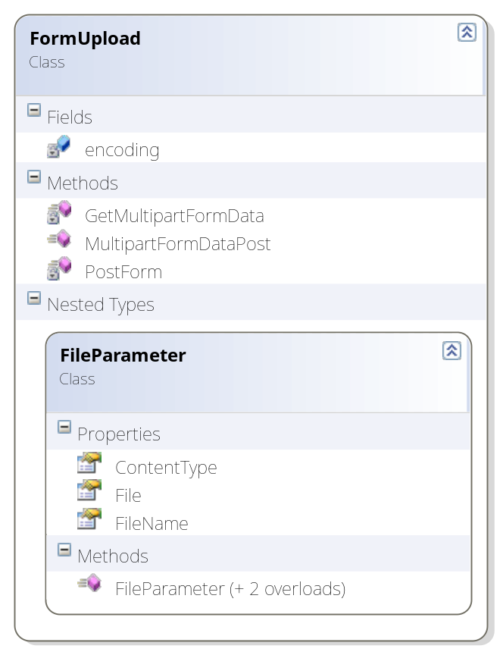

This class is used to conduct the multipart upload when publishing the model.
The file data (byte array) and form options (overload == checked) are specified when calling the PostForm method.

This class should be treated as a black box and should not need to be modified.

The Ribbon
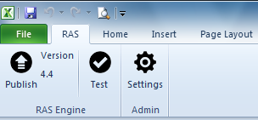

On load, the ribbon gets the current version number from Custom Document Properties and updates the label.
The minimum amount of logic has been included in the ribbon, leaving that to classes and forms as appropriate.

Settings and Test buttons merely show the relevant forms.
Publish stores the current and selected new version numbers, attempts to validate (using IsValid method of the CalculationModel class) and publish the form (using Publish method of the CalculationModel class) and, if successful, updates the version number label.

Forms

Settings Functionality
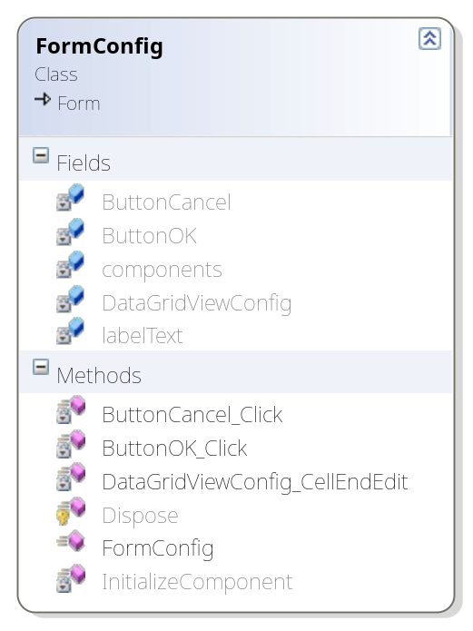
The Settings form is mainly a DataGridView with an editable right column. On load, the grid is initialised from document properties and populated.
If any properties are empty (null or blank string) then the row is highlighted in red.
As values are populated, the row turns back to white.
On Cancel, the form is disposed.
On OK, the values are written back to Custom Document Properties.

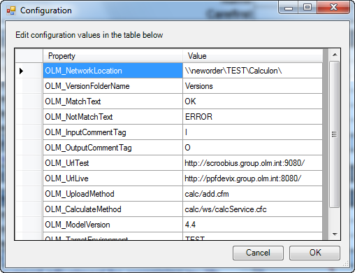
Publish Functionality

On pressing Publish, the FormPublishVersion dialog is presented (see below). On load, CalculationModel.GetVersionNumber method is used to derive the next minor and major version labels.
The user can select environment: TEST (Default) or LIVE.
Note: currently the Settings and CalculationModel cater for TEST and LIVE urls. This may be enhanced to allow users to create any number of named urls.
The user also selects major or minor version update.
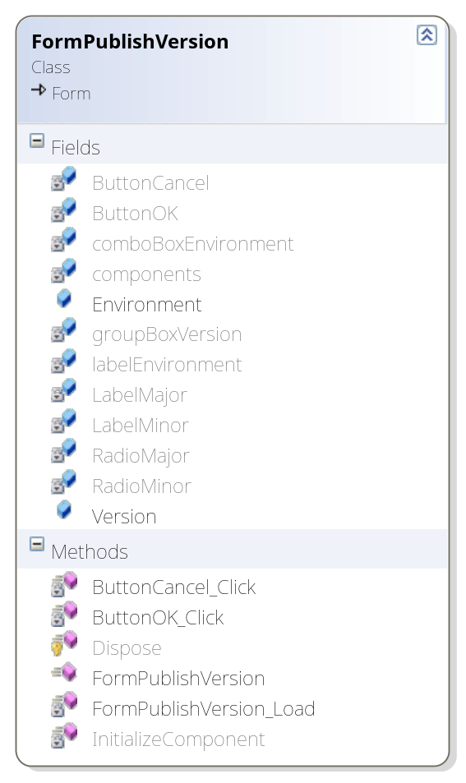
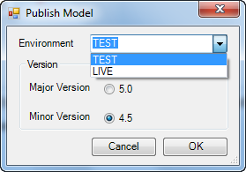

This dialog returns properties Version and Environment to the caller.

The rest of the Publish workflow described above in Ribbon section is then carried out.

Test Functionality
On pressing Test, the FormResults dialog is presented. This is mainly a DataGridView as shown below.
On load, a four-column array is initialised with header row values.
The CalculationModel.Test method is called, which does the following:
- Gets the list of inputs from workbook
- Serialises them into a request method
- POSTs the message to calcService web service
- Deserialises response into results list
- Matches results with outputs list (CalculationModel.MergeResults method) to populate a four column array
The results are bound to the DGV.
Any rows where Match column value is unmatched will turn red.
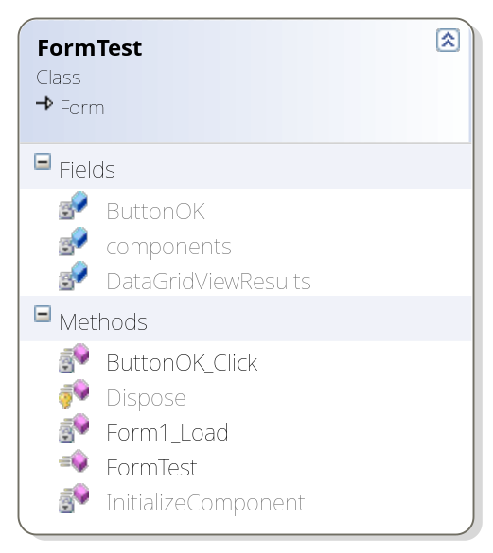
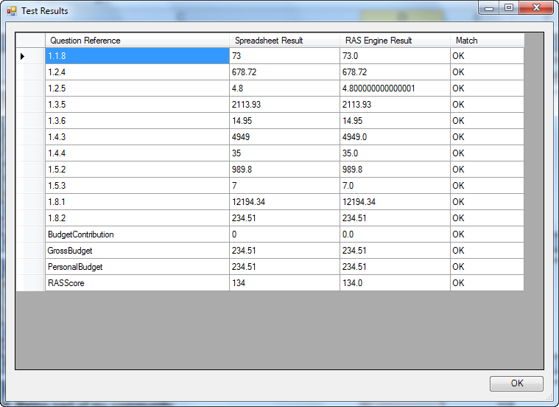
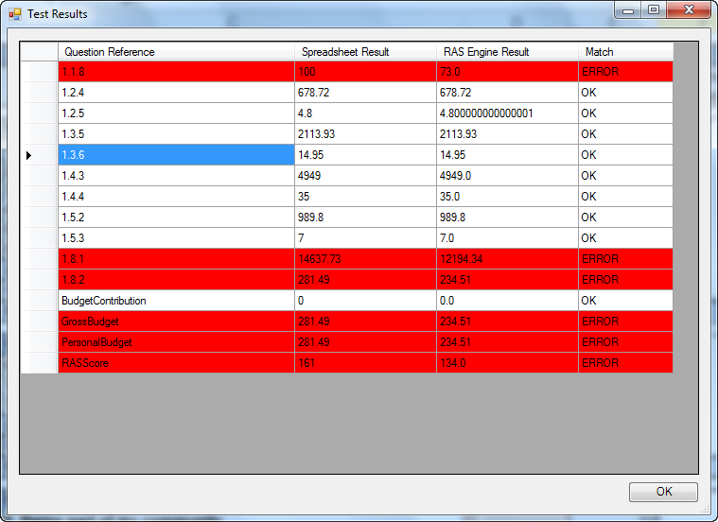

Publishing the Product
The Add-In should be signed with the OLM digital certificate and published as a .vsto runtime (rather than an MSI package).

